Power BI Assignment 1

Solution 1:
Report View
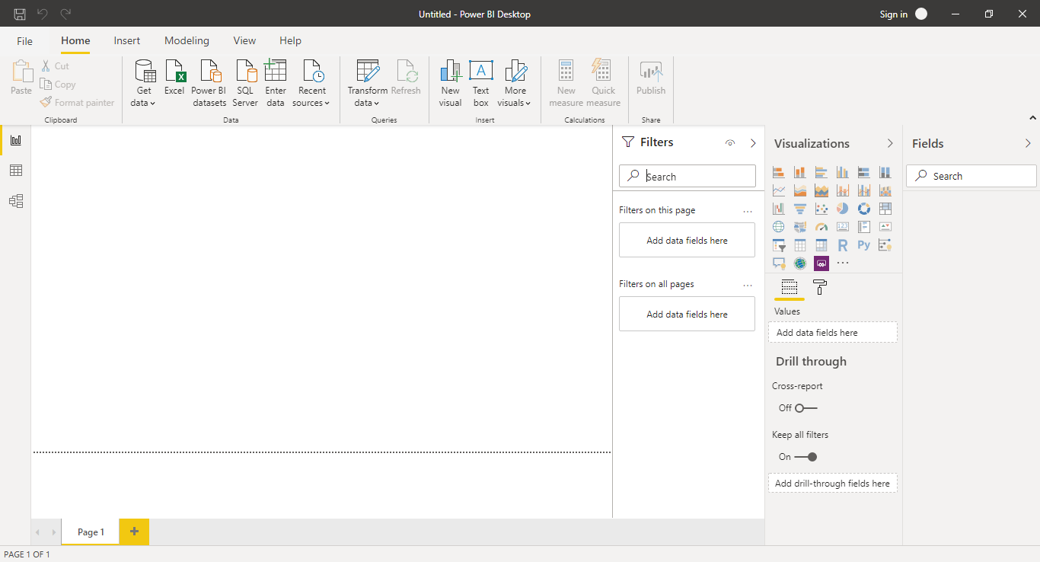

Solution 2:
Report View:
Report View in Power BI is a space where visual analysis actually takes place. This is the place where all visualisations are present and we build our dashboard.
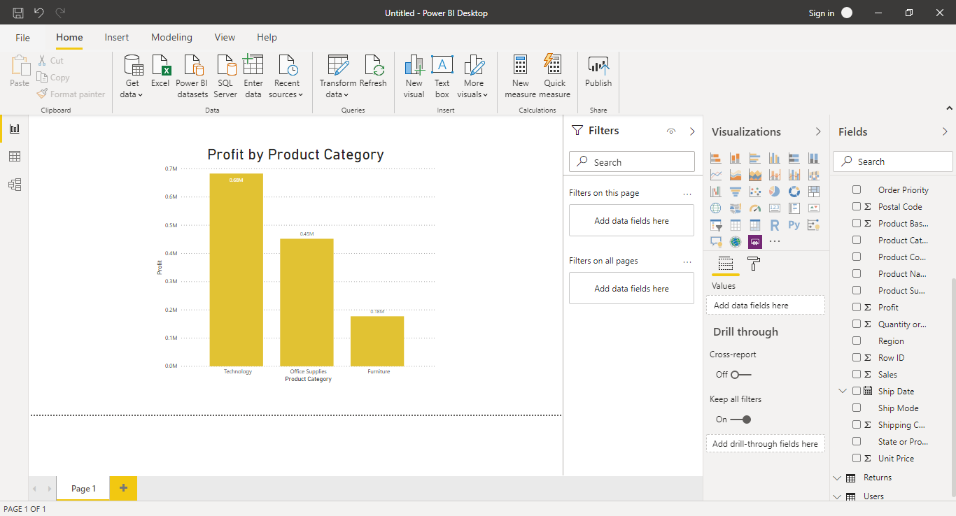
Data View:
Data View is a place where we explore the data in a tabular format.
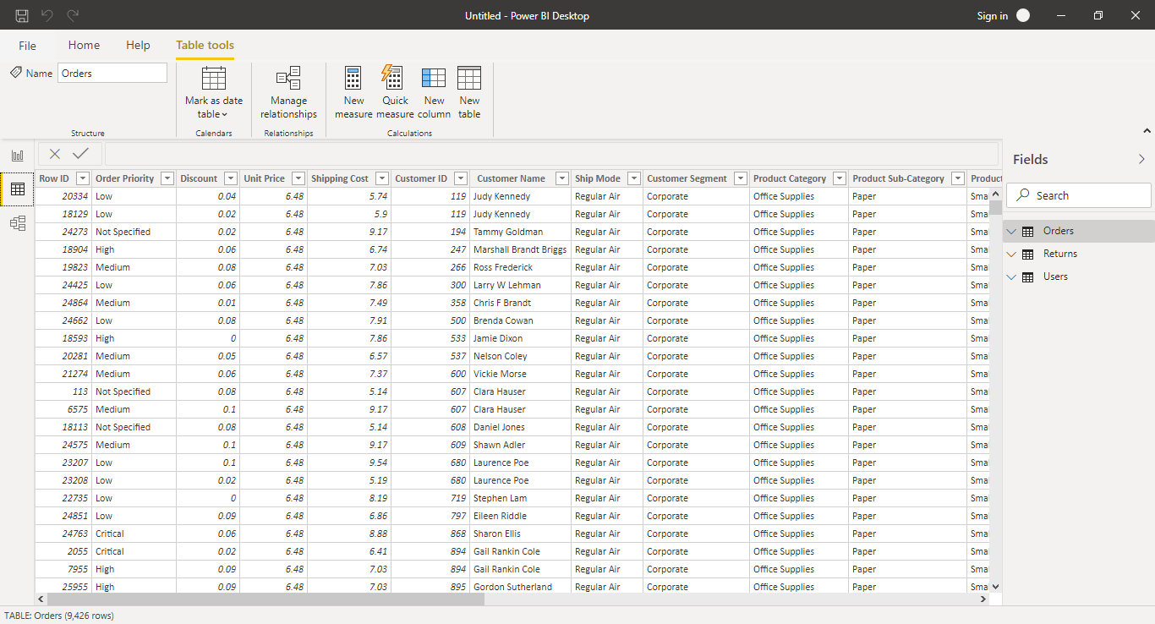

Model View:
Model View is a place where we see relationships between different datasets.
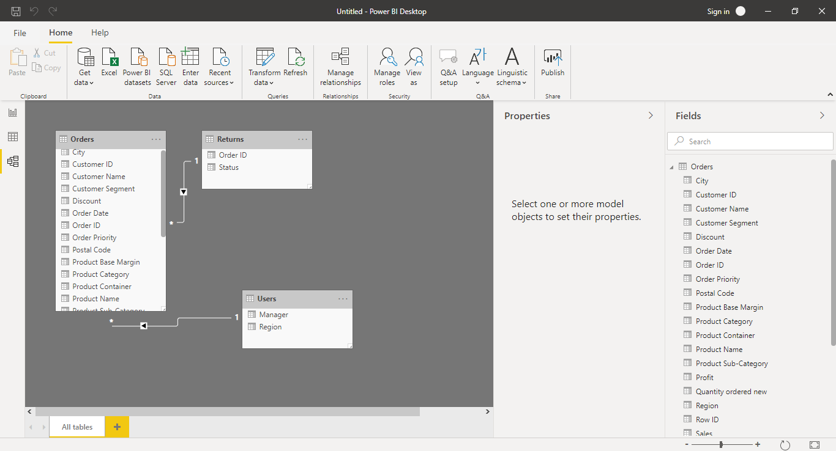

Power Query Editor:
Power Query Editor is a separate window within Power BI where we can transform data. In other words, it is a tool to accomplish ETL (Extract, Transform and Load) tasks within Power BI.
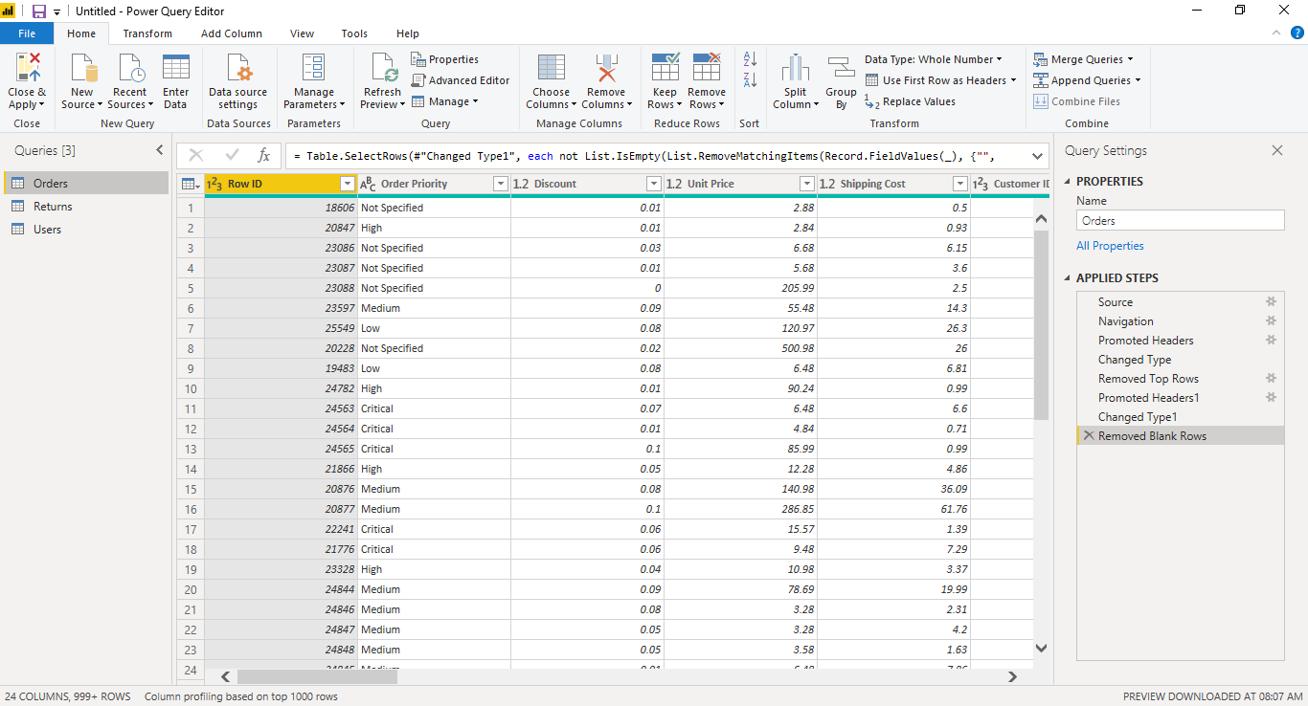

Advanced Editor:
Advanced Editor is a place where any transform operation done on any dataset/ table is stored in the form of a code. This is also a place where data transformation can be done programmatically.
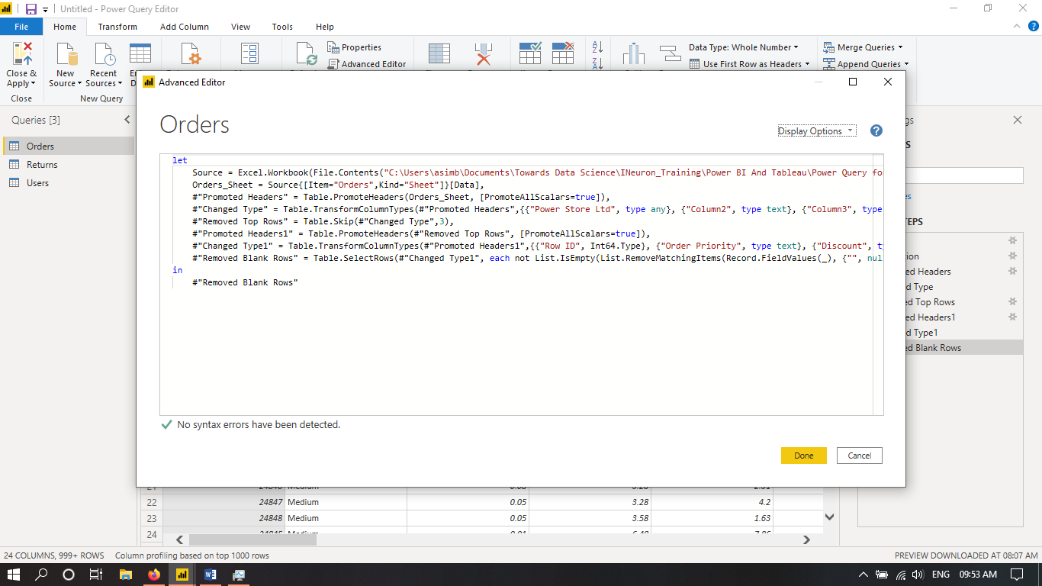

Solution 3:
Power BI Desktop:
Power BI Desktop is a free version of Power BI which can be installed on local computer systems. It is supposed to act as a companion to the full version of Power BI. Some features of Power BI Desktop are:
- Connect and import data from over 70 cloud-based and on-premises sources
- The same rich visualisations and filters from Power BI Pro
- Auto-detect that finds and creates data relationships between tables and formats
- Export your reports to CSV, Microsoft Excel, Microsoft PowerPoint and PDF
- Python support
- Save, upload and publish your reports to the Web and the full Power BI service
- Storage limit of 10 GB per user
Some limitations of Power BI Desktop are:
- Can’t share created reports with non-Power BI Pro users
- No App Workspaces
- No API embedding
- No email subscriptions
- No peer-to-peer-sharing
- No support to analyse in Excel within Power BI Desktop
Price: Free

Power BI Pro:
Power BI Pro is a full version of Power BI. It allows building dashboards and reports, as well as unlimited viewing, sharing and consumption of created reports. It is licensed to individuals.
Price: Rs. 660 per month per user

Power BI Premium:
Power BI Premium is the most powerful offering of the BI Tool by Microsoft. It allows increased data capacity limits and improved performance. It is also distinct from Power BI Pro in terms of number of refreshes it allows. Power BI Premium is licensed by cloud compute and storage resources required.
Price: Starts at Rs. 3,30,190 per month per cloud compute resource

